The Newsroom:

My Experience as a WPRI Digital News Intern

AJ Beltis

Bryant University

Spring 2014

I had to skip my Marketing class to go to my academic internship orientation for the 2014 Spring semester. It was Thursday, January 30, 2014 - my first trip to WPRI. On my way in to Providence that day, I missed two exits, parked in the wrong lot at WPRI, and showed up in the waiting room with less than a minute to spare. Not off to a great start.
Once all the interns were in the same place, the supervisors walked us all around, showing us the break room and the vending machines, but also the tech room, the set for the News and for The Rhode Show, and most importantly, the newsroom.
This internship worked out perfectly because I got to work with my good friend Angie Angers as my direct supervisor. She was a senior while I was a freshman at Bryant, and we worked together in such Bryant activities as The Podium and the Media Production Club. She secured a job as a Digital Content Producer at WPRI before her graduation. Going in knowing somebody definitely made the transition smoother. She was able to convey expectations easily, there was no awkward tension of getting to know one another, and she could be frank with me about my mistakes, and so I was able to get right into learning things and making my time at WPRI mean something.
My first day was rife with new experiences. When I went in on Tuesday, February 4, I was given a WordPress ID for the website (though as an intern I wouldn’t be allowed to publish my own stories without approval) and access to their LinMedia editing software. With the Anvato Lin software, I was taught how to clip. Basically, that involves going to a site where the live newscast video uploads. The digital newsroom employees then go on this site, clip individual news stories, and give them names and descriptions. Later, they would find an ID for the video and include it into the clip’s corresponding written story. Apparently, I caught on relatively quick, as soon after I started, Angie bragged to head of Digital News Nancy Krause that I was “already doing real-time clipping.”
Angie cautioned me to make sure the titles of my videos and writing were good. When I clipped a Call 12 For Action clip about a warranty discrepancy between a local woman and Target, Angie told me that “Warranty Wars,” while catchy, wasn’t a “title.” Granted, I forgot to give a description a couple of times on the first day in the clips, causing Angie to tell me to slow down and make sure everything was complete before I pressed “save.”
What I was most excited and surprised about during my first week was being able to write. Maybe it was just because Angie knew me and knew I was capable. On my second day, I covered a story of an older driving instructor accused of sexually assaulting a driving student. Angie looked it over, made a few technical edits, but told me it was a well-written story for a first-day intern. My internship was officially off to a great start, and my name was officially on the WPRI website as a published news story author.
My next week, I went in during a blizzard (which Angie made note of during my mid-performance evaluation). I learned to construct a PhotoMojo for an interactive photo album. That day, I made one for the snowstorm. A feature of WPRI is ReportIt!, where viewers send in pictures relating to a top story. That day, dozens of people sent in photos of their kids and pets playing in the snow. Angie instructed me to go through and pick the best ones (subjectively, of course).
Over the next few weeks, things stayed pretty standard as I gradually met new members of the WPRI team. Writing a bit, clipping a bit, then working on lengthier stories with Angie until 9:00. Soon, Angie came to me with a new task. She told me if I wanted to, I could run the teleprompter for the live newscast. While I was excited for this new venture, I have to admit I was petrified. If I screwed up, the anchor would screw up. If the anchor screwed up, the show was basically over. The success of the entire news program that thousands of people were watching was on the shoulders of a 19-year-old intern who never used the equipment before. Sure, I had the usual worker over my shoulder in case anything went wrong. But still – no pressure, right?
The room was filled with monitors of all of WPRI’s affiliated station (CBS, FOX, and MyRITV), as well as live shots of all the cameras in the news set and one for Tony Petracca’s weather forecast. Finally, one screen had the live teleprompter words on it. I was told to keep up by having the anchor’s words be towards the middle of the top of the screen, to keep a good pace, and to tune out all background noise so as not to lose focus.
Thankfully, I didn’t screw up. Although one time, a few weeks later, I scrolled way far ahead during a package. It luckily wasn’t during a live reading. But still, thoughts of “oh crap oh crap what do I do what do I do?” came running through my mind. Sam, the employee who ran the teleprompter, told me to stop (repeatedly) and to take it back up, and by the time it got back to the anchor’s live reading, we returned to the regular place.
After that night, the shift became pretty routine.
4:00-5:00: Write a basic news story – usually Call 12 for Action. If I finished early (which I usually did), I would proofread the main stories.
5:00-6:30: Clip for the live newscasts.
6:30-7:00: Run the teleprompter and pray that I don’t mess up.
7:00-7:30: Eat dinner, usually do some minor things like proofreading.
7:30-9:00: Work on about 2-4 stories, go over them with Angie to see if she likes them or not, and find out what I need to do better next time.
Some days, Angie would take the night off. And unfortunately, with about a month left, Angie was asked to switch her shifts, meaning I would only get to see her for about two hours a day. However, I ended up being able to work with Shaun Towne – another skilled news writer and fellow movie enthusiast. On slow nights, we’d talk about movie trivia and effective uses on cinematic long takes with Sam. One night, we even got Eyewitness News anchor Mike Montecalvo involved. My routine pretty much stayed the same with Shaun, and he taught me interesting facts that Angie never did, like never leading a news story with a question.
What I think I like most about WPRI is their honesty and accuracy. When any initial reports started coming in, Angie told me to wait because Eyewitness News prides themselves on their accuracy. I wasn't allowed to refer to Dzokhar as "The Marathon Bomber" because he hadn't been convicted yet, and we're not allowed to "accuse" anyone. We were required to relinquish bias or opinion and instead live up to the slogan of “Coverage you can count on.”
During my internship, I would switch things up occasionally to get a taste of the different operations of WPRI. One day, I went on The Rhode Show with Angie to promote Bryant’s Public Speaking Colloquium, and got to talk about the event in front of thousands of people on live TV. Commuting into the city during rush hour wasn’t ideal, but it’s something I’m sure I’ll have to get used to in the coming years. Also, the lack of classes on REDay allowed me to go in during the day shift that day, work on writing stories for The Rhode Show, and clipping for a different news cast.
On my last day, Angie called me over to show me “the perfect last day gift.” A story I wrote the night before with Shaun – focused on a baby with anencephaly who survived – got picked up and linked by CNN. Both Angie and Shaun seemed really happy for me, which really affirmed that I made an impact during my time at WPRI.
It still hasn’t hit me yet that my time at WPRI is over for now. While digital news (or even news for that matter) might not be the path I eventually decide to go down for a career, I wouldn’t trade my time, experience, or newfound skills for anything.
Looking back on this experience, I can tell people I spent over 100 hours working in a professional newsroom, contributing to the on-air newscast, appearing on The Rhode Show, and writing over 50 news stories that thousands of people saw. I can tell people my writing got linked to CNN. I can tell people I was in the newsroom the same day a man dropped a backpack full of confetti at the Boston Marathon finish line, Smithfield High School went on lockdown, a building in Boston caught fire, and Gordon Fox went back into the State House after his home was raided. Better than that, I can tell people I wrote one of the stories that they might have read when that day came around. Hopefully, this internship was just the start of greater things to come.

An archive page of some off my published stories can be found here: http://wpri.com/author/austinbeltis/

iNEWS on the right, the publishing website (WordPress) on the left.

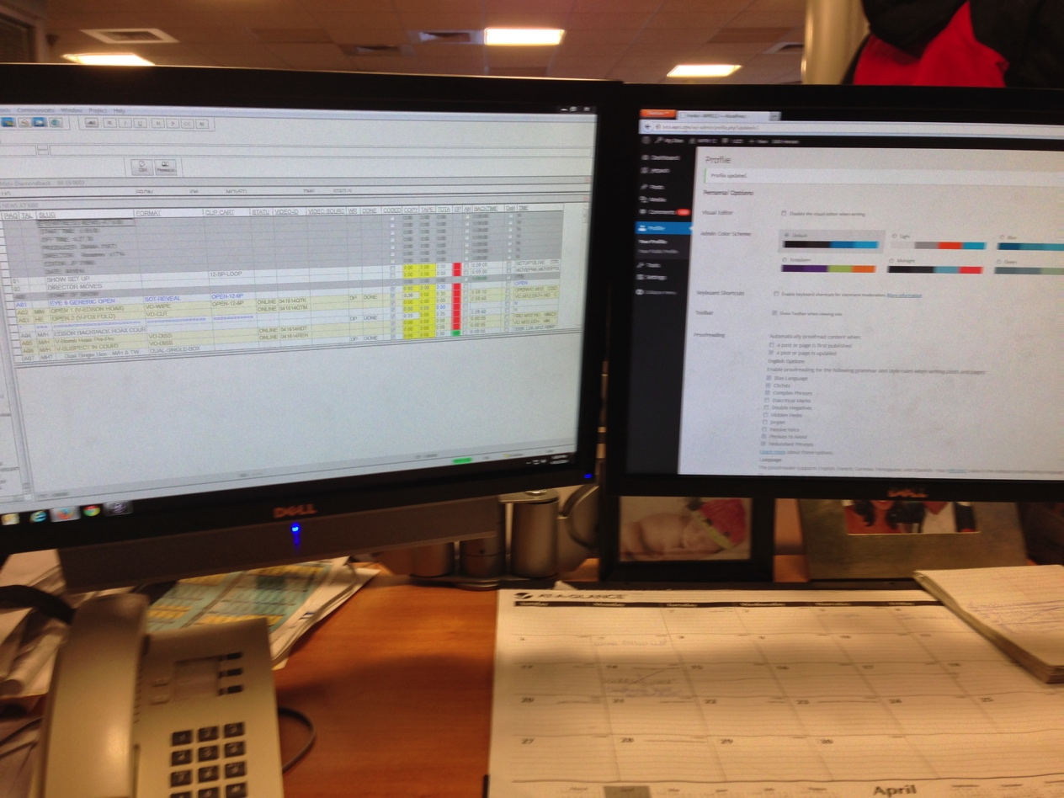

In the Eyewitness News newsroom

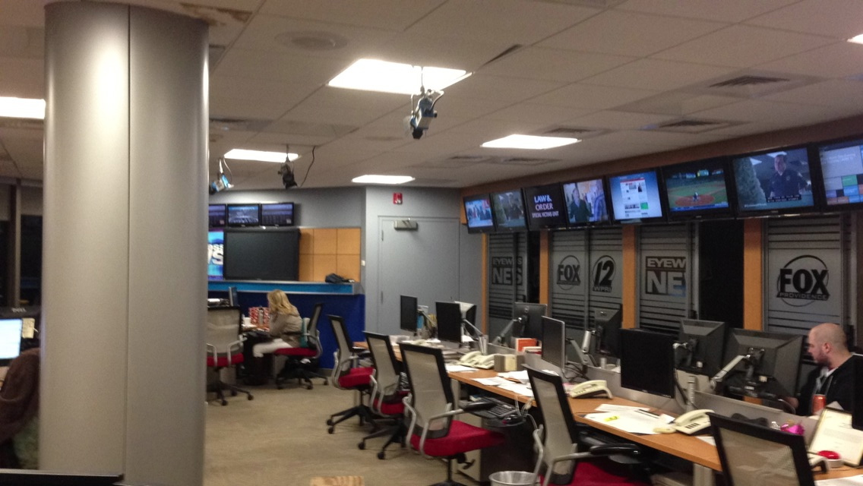

My desk/working area (I spy Angie Angers & Ted Nesi!).

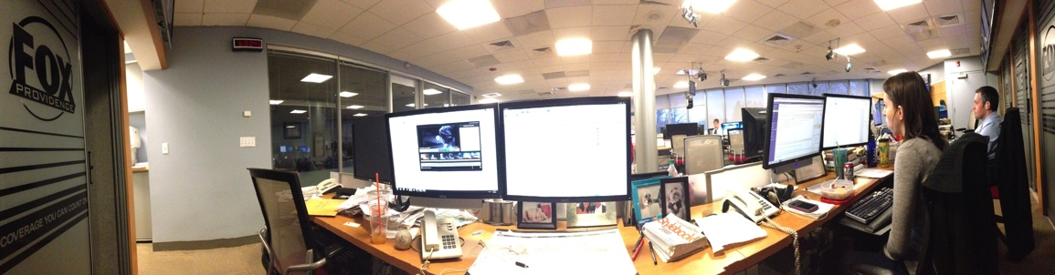

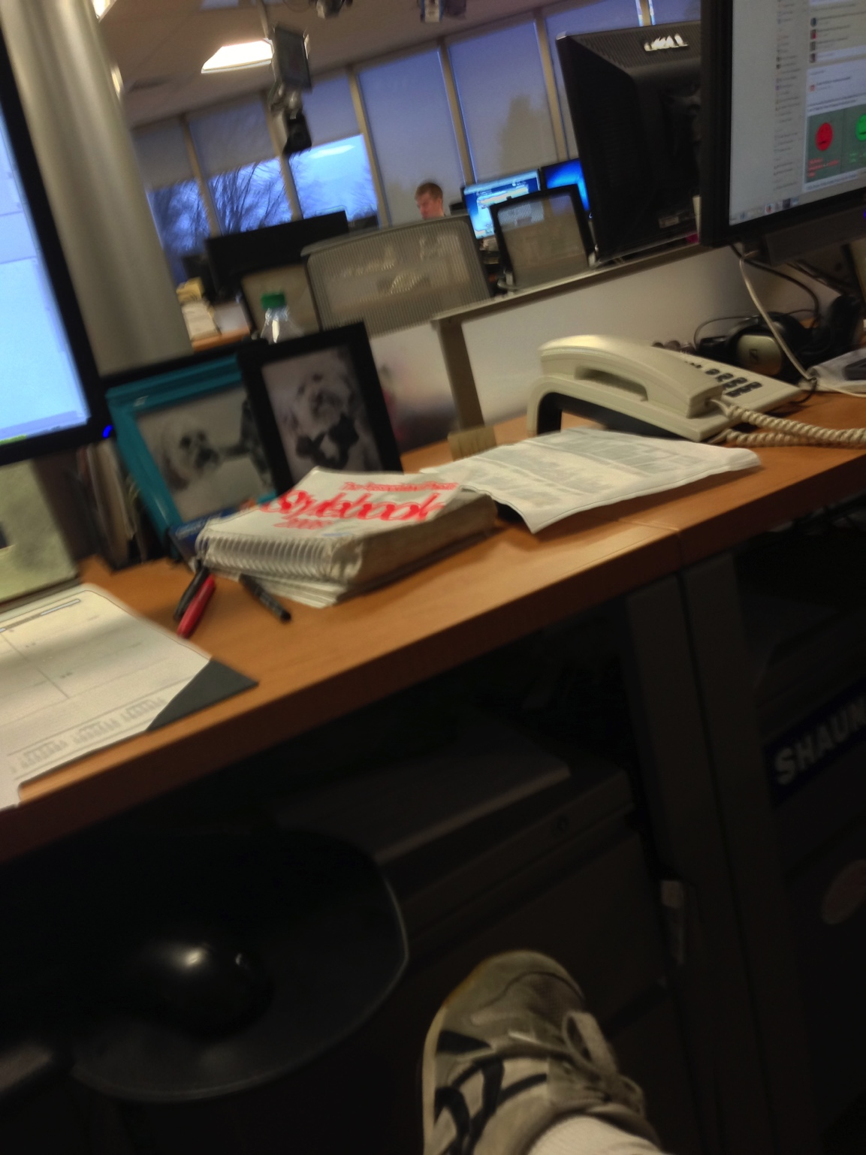

The broadcast room where I ran the teleprompter (overwhelming, to say the least).

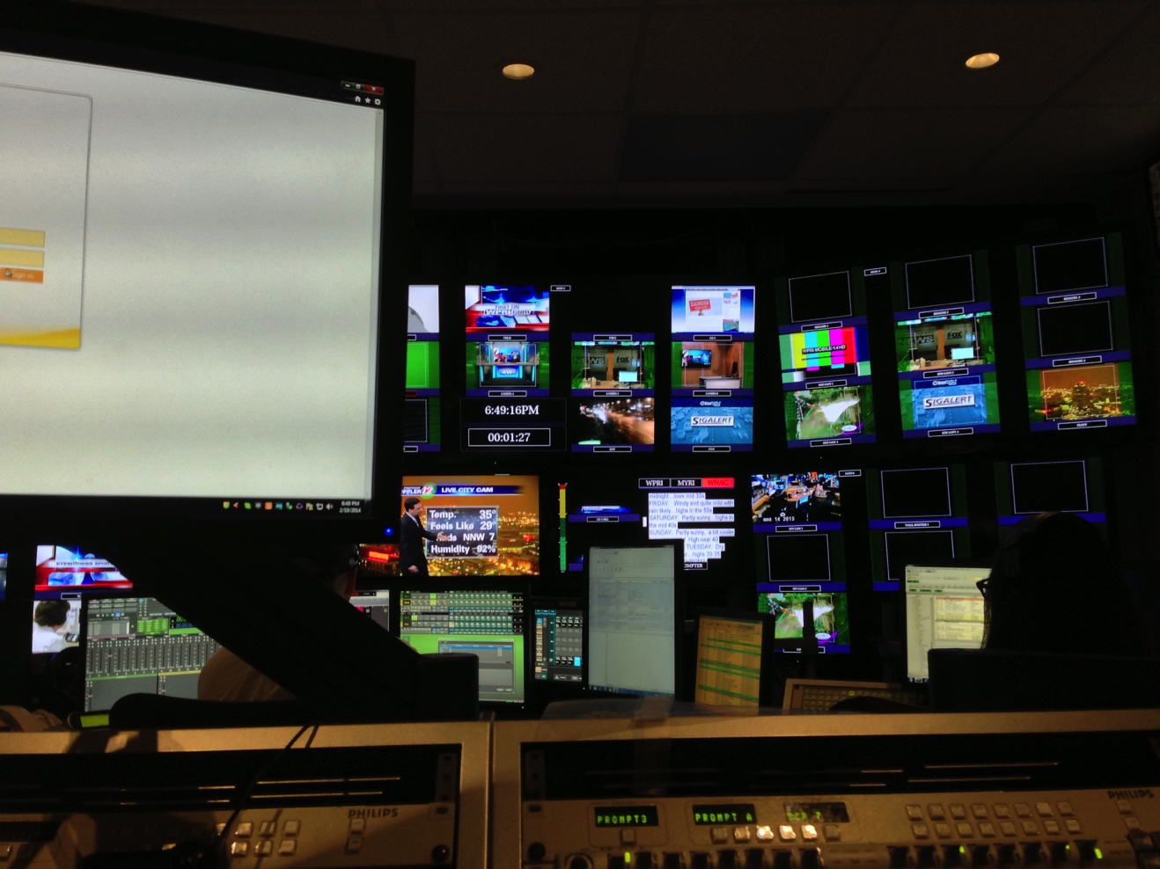

My first published news story (notice how Angie has to published alongside me).
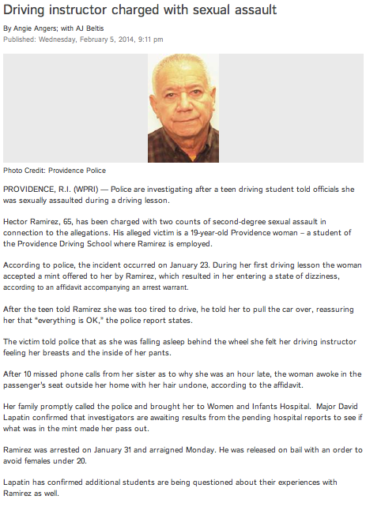
My linapps PhotoMojo for the day of the blizzard http://interactives.wpri.com/photomojo/gallery/10871/208375/photos-early-february-snowfall/snow-friend/
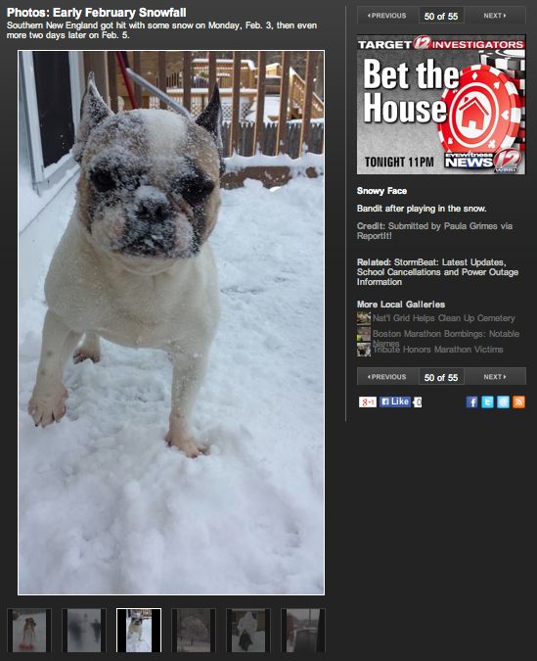

Me on The Rhode Show (notice the attention to detail in the spelling).
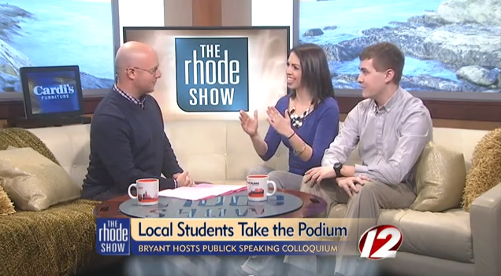

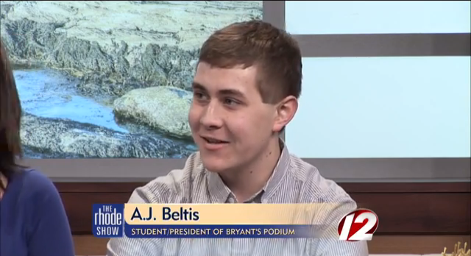

The Anvato webpage I use for clipping news videos.
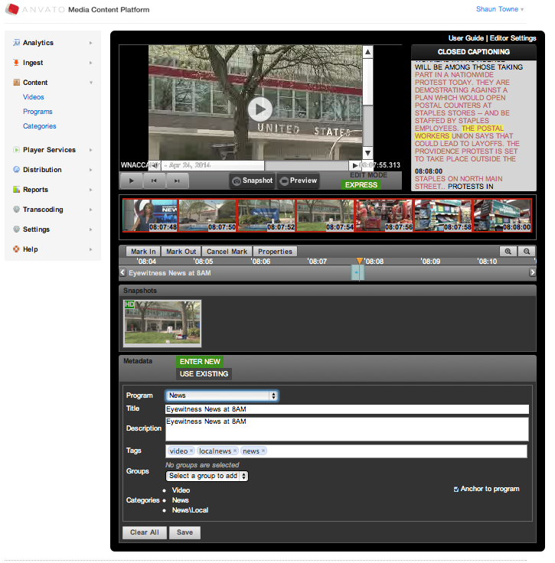

A Call 12 for Action story I covered (always credited to Susan Hogan). Angie said she liked the humorous spin I put on it.
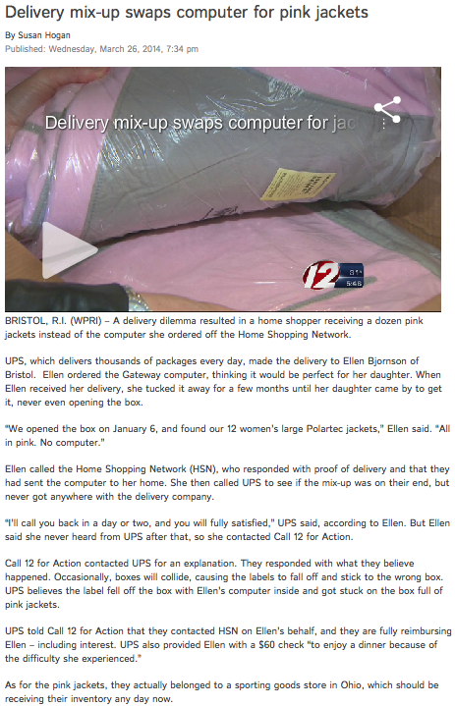
One of many stories I wrote about police looking for a suspect. Angie showed me a site called “ipiccy” that allowed us to format that photo of the suspect seen below.
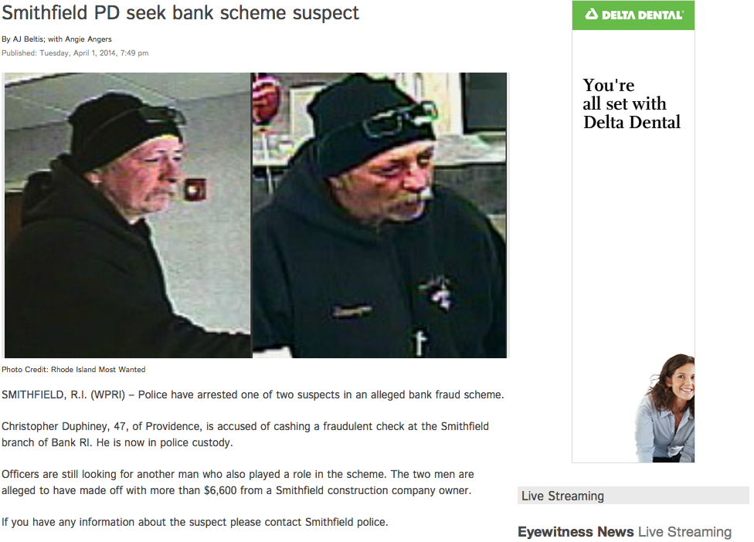

A story I wrote that got picked up by CNN!
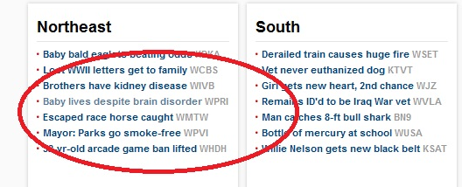
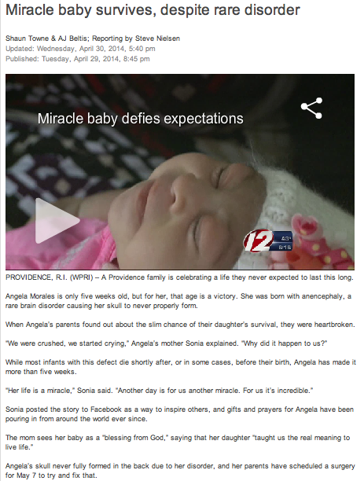
A story I covered in the aftermath of the Smithfield High lockdown.
